Industry Insight Article – PR Newswire Internal Publication March 2017
Earned Media: A Powerful Marketing Tool
Who’s heard of Carter Wilkerson? Anyone?
You probably haven’t. But I’ll bet you’ve heard of Wendy’s offering someone a free year of nuggets in exchange for 18 million retweets on Twitter.
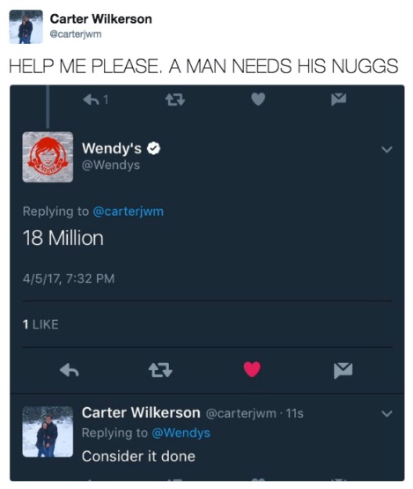
Carter Wilkerson is the teenager who brokered this impromptu deal on Twitter, and he’s also Wendy’s new favorite person. Why? Because, as of writing this, Wilkerson has advertised about the deliciousness of Wendy’s nuggets to nearly 2.9 million Twitter users, and Fortune, Fox News, CNBC, and People magazine have all reported on the story. For free.
This is earned media.
Earned media is changing the way we view brands and business models. It is the media buzz and coverage that is literally “earned” by creating content persuasive enough for reporters or other 3rd parties to write favorably about a product or brand. Unlike the more traditional marketing channels of paid media (commercials, ads, press releases) or owned media (blogs, websites), earned media has much higher measurability and ROI. And 92% of consumers trust earned media, compared to the 24% who trust paid ads.
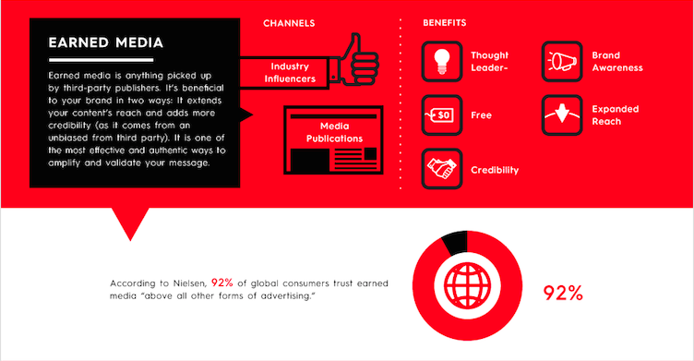
But does that mean paid media no longer has a place in marketing?
Of course not. Wilkerson’s tweet isn’t the solution to Wendy’s marketing needs. It’s only a piece in a much larger puzzle. Earned media is meant to organically grow a brand following, but paid media can help promote initial growth through consumer targeting and reach. As the name suggests it’ll cost money, but the result is guaranteed placement.
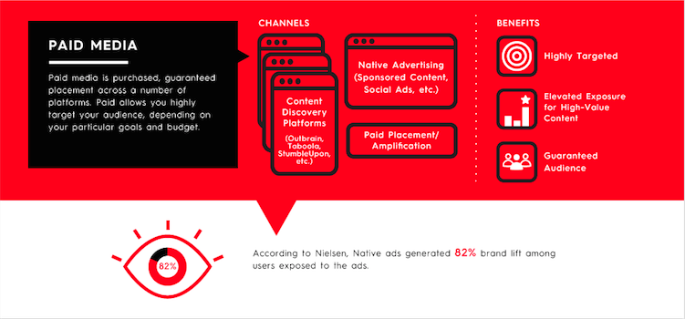
The best marketing strategies will use all forms of media—paid, owned, and earned—to complement each other and achieve greater results. The press releases we distribute at PR Newswire often offer a window into these types of fluid strategies. For example, a company might distribute a release announcing a new product. The release could contain a call to action to view related content on an owned site. Journalists who then engage with the release and content are sparked to create earned media that is subsequently shared on social media. The success of the company’s campaign is detailed in another press release, and the cycle begins again. Paid, owned, and earned media in concert with one another.
So, rest easy, PR Newswire. The press release is not dead. And neither are Carter Wilkerson’s dreams of Wendy’s chicken nuggets.

